The Progressive Era
Institution
Course
Name

Table of Content
- What does it mean to be a progressive in the US……………………………………1
- Progressives see a leader in Bernie Sanders as they prepare to fight back ………… 9
- Today’s Democratic party is the opposite of the New Deal coalition ………………18
- The Rise and Fall of the Progressive Movement in America ………………………..23
- The Progressive Century ……………………………………………………………..24
- Gender, Class, Race and Reform in the Progressive Era …………………………….25
- American Progressive Education And The Schooling Of Poor Children: A Brief History Of A Philosophy In Practice …………………………………………………………..26
- Progressivism, Schools and Schools of Education: An American Romance ………….27
- The Winds of Change: The Progressive Movement and the Bureaucratization of Thrift.28
- Visual Sources ………………………………………………………………………….30
- Websites ………………………………………………………………………………..31

The Progressive Era
Primary sources

What does it mean to be a progressive in the US?
By Tara McKelvey
White House reporter, BBC News
Published
5 February 2016
Share
Related Topics
- US election 2016
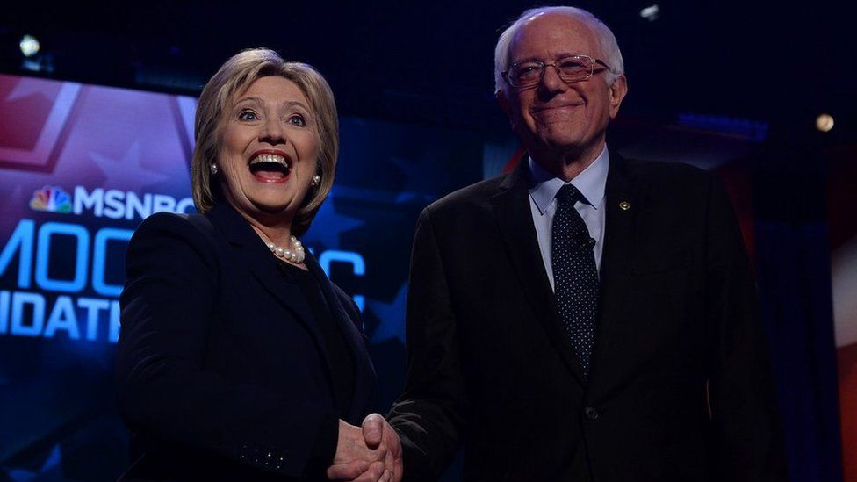IMAGE COPYRIGHTGETTY IMAGES
image captionDuring the campaign, Bernie Sanders and Hillary Clinton have argued over who is a progressive
Two Democratic candidates for the US presidency, Senator Bernie Sanders and Hillary Clinton, are fighting over the term "progressive". But what does the word really mean?
In a CNN town hall on 3 February in New Hampshire Mr Sanders and Mrs. Clinton argued over what the word "progressive" means and who has the right to describe themselves in this way.
Mr Sanders said she's not a liberal when it comes to foreign policy and other issues. She disagreed with him, saying that she's "a progressive who likes to get things done". She added that she was "amused" that he'd "set himself up as the gatekeeper of who gets to be a progressive".
So what is a progressive?
Politicians, activists and others disagree about what the word means. Historians concede that there's no precise definition. Still they say that in general a progressive fits certain criteria.
A progressive is someone who wants to see more economic and social equality - and hopes to see more gains in feminism and gay rights. They're also supportive of social programmes directed by the state - and they'd like social movements have more power in the US.
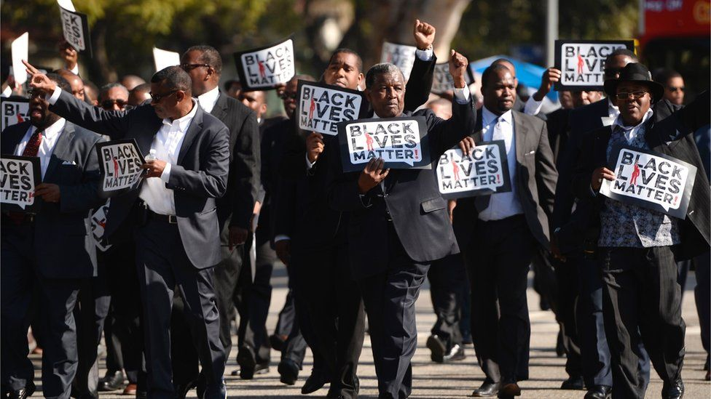IMAGE COPYRIGHTAFP
image captionProtesters in Black Lives Matter - shown in Los Angeles - and other activists belong to the progressive movement
Within the realm of progressive, however, there are different, warring factions, explains David Greenberg, the author of a book called Republic of Spin: An Inside History of the American Presidency.
One group is dominated by activists from social movements such as Occupy Wall Street and Black Lives Matter, he says, and the other is led by those who belong to the left wing of the Democratic Party (and aren't part of a social movement or cause).
Pretty much all of of these progressives "view politics as a bottom-up progress", says Julian Zelizer, an historian at Princeton, and they support the fight for social change. (Though not everybody is on the streets, clamouring for it.)
They also believe that the government can help people, and they look back fondly at Roosevelt's New Deal jobs programs, which relieved suffering in the 1930s.
For these reasons they see the world and its problems in a similar way, but they often have different ideas about how to fix them. Nearly all progressives agree that banks should be regulated, for example, though they argue about how it should be done. Some believe the regulation should be aggressive - and dramatically change things.
Bernie Sanders, says Greenberg. "wants to break up the banks".
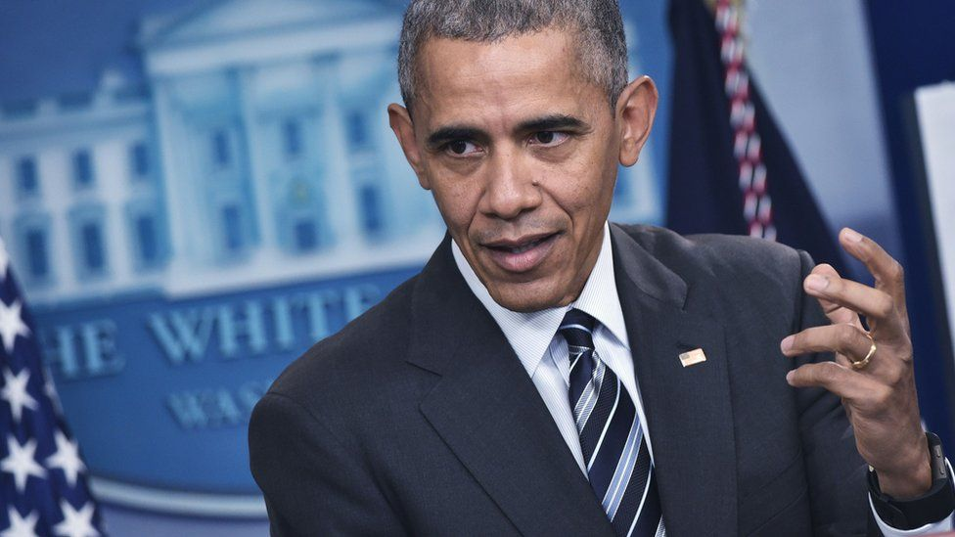IMAGE COPYRIGHTGETTY IMAGES
image captionThe left has gone through a revival under President Barack Obama, say US historians
Others are more moderate in their views. Mrs Clinton agrees with him in principle, says Greenberg, "but she doesn't want to do it willy-nilly".
But regardless of how they see the issue of banking, they're proud to call themselves progressive. For Democrats it's a coveted term. But it wasn't always that way.
Conservatives attacked a Democratic presidential candidate, Michael Dukakis, for being too lefty in the 1980s and tagged him with the word "liberal" . "It was seen as a dirty word," says Zelizer.
Afterwards Democrats tried to distance themselves from the term. When Bill Clinton ran for president in the 1990s, he tried hard to avoid the world "liberal".
During his campaign he cited economic research from a think-tank, the Progressive Policy Institute, and in this way he could promote "liberal economics without calling it liberal", says Greenberg.
In recent years Democrats have seen the notion of progressive politics in a different light.
The left has gone through a revival under President Barack Obama, says Michael Kazin, who teaches history at Georgetown University in Washington. explaining that "the Democratic Party has become a progressive party".
The fact that Democratic candidates are now fighting to show how progressive they are shows the way things have changed. As Zelizer says: "It signals that there is more room for the left in American politics than there's been for a while."

Related Topics

Progressives see a leader in Bernie Sanders as they prepare to fight back
This article is more than 4 years old
Sanders supporters ready to take on Trump as progressives’ voices grow louder after the election: ‘We have to do what the Tea Party did’
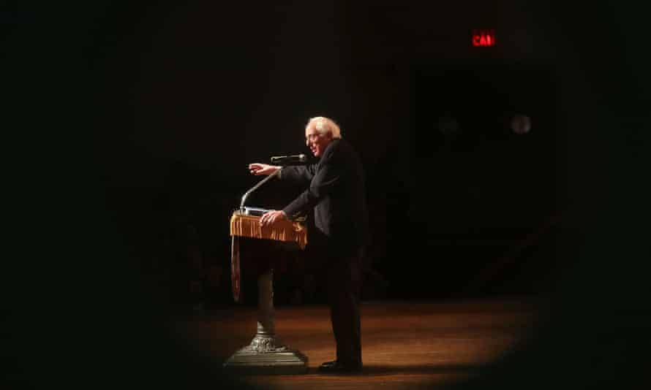
Bernie Sanders speaks in New York: ‘He’s like the Energizer bunny,’ says a supporter. Photograph: Spencer Platt/Getty Images
Lauren Gambino in Washington and Adam Gabbatt in New York
Wed 28 Dec 2016 12.00 GMT

1,628

1,246

It wasn’t meant to be like this.
Hillary Clinton was supposed to be president. The Democrats were supposed to be competitive in the Senate and the House.
In that scenario, Bernie Sanders, the democratic socialist senator from Vermont, might have been in effect sidelined as Democrats hunkered down for four years of a steady, if unspectacular, continuation of Barack Obama’s centrist agenda.
But instead, Donald Trump won the election – with an anti-establishment message that bore some similarities to Sanders’ own government-outsider election bid – and Sanders has found himself promoted from anti-establishment outsider to the Democrats’ leadership bench.

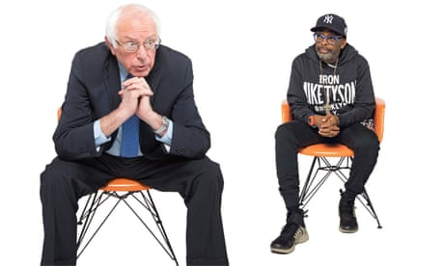
Bernie Sanders meets Spike Lee: ‘Where do we go? Where is the hope?’
Read more

Indeed, some Sanders progressives now see Trump’s victory as a validation of the populist agenda Sanders championed during his campaign.
“Progressives are used to punching up, but here we find ourselves in a real position of credibility and power,” said Raul Grijalva of Arizona, a co-chair of the Congressional Progressive caucus.
As the party seeks to rebuild in 2017, caucus members believe the election of the DNC chair is an early test of whether Democrats will embrace economic populism.
Advertisement
Sanders’ first priority is to elect Keith Ellison, the progressive congressman from Minnesota, as DNC chair. Ellison, who is seen as the frontrunner, is being challenged by the labor secretary, Tom Perez, who enters with support from allies of Clinton and the Obama administration.
“Right now we are fighting for the chair of the DNC and it is truly emblematic of the division within the Democrats,” said RoseAnn DeMoro, executive director of the National Nurses United, which endorsed Sanders during the primary. “If the Democratic party rejects the Sanders base, it will be at their extreme peril.”
On a tactical level, all eyes are on 2018 and how to elect progressives to seats at the local, state and national level.
“We have to do in 2018 what the Tea Party did in 2010,” said Dan Cantor, the founder and executive director of the Working Families party.
Though Sanders has become synonymous with the progressive movement, activists say 2017 won’t hinge on voters feeling the Bern. It will be about empowering the next generation of progressive leaders.
“We need younger voters to get engaged and to lead, and not just in political office. We need young shop stewards and young activists, too,” said Larry Cohen, the former president of the Communications Workers of America and the head of Our Revolution. “We older people need to move over and encourage these young people to rise up. That’s where the energy is. That’s where our future is.”
Moumita Ahmed is among those young activists working to capitalize on the gains Sanders made in 2016.
She is one of the organizers of the million millennials march, which will take place in Washington the Saturday after the inauguration, and she said Sanders had an important role to play in telling his supporters how they can get involved in grassroots activism.
“He’s the one with the platform. He’s the one who’s going to get media attention,” Ahmed said.
“So he really needs to let people know what the grassroots is doing – so that we can absorb people’s energy.
“Because there’s so many people who are out there right now who don’t know what to do, but they’re ready to do something. So Bernie can sort of focus everyone.”
Charles Lenchner, co-founder of People for Bernie, an independent group which campaigned for Sanders during the Democratic primary, said Sanders was already showing a willingness to fill that role.
“Just look at him,” Lencher said.
“He’s like the Energizer bunny. He’s running around every single day. There’s press releases, there’s town halls, there’s livestreams.”
Sanders held one of those town halls in Kenosha, Wisconsin, on 13 December. He managed to find common ground with Trump supporters in the audience on the ills of trade deals like the North American Free Trade Agreement and on the failure of establishment politics.
Alongside public appearances, Sanders also set up the “Our Revolution” organization, which aims to harness the energy that the Vermont senator’s presidential bid created.
In the November election, Our Revolution threw its support behind progressive candidates, encouraging people who had supported Sanders to fundraise and door-knock for local politicians.

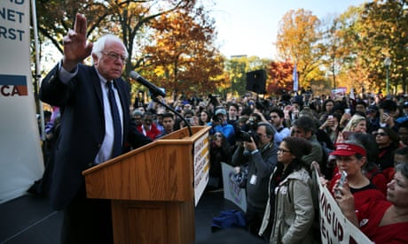
Bernie Sanders rallies supporters with call for new direction in Democratic party
Read more

Our Revolution’s website has a list of ballot initiatives that activists can support and a calendar of events that people can attend.
But Lenchner said progressives should be wary of relying solely on Sanders to lead a grassroots movement.
“His job is to be a legislator and hold the right positions and to message on the issues. But then it’s up to us in the movement to do with that what we will,” Lenchner said.
“Our job is much more at the level of our own communities, our own constituencies, our own organizations.
“Our job is to create the wave that is going to push back against Trump and his allies in elections.”

Progressives are a minority in America. To win, they need to compromise
Michael Lind
This article is more than 2 months old
Rebuilding something like the New Deal coalition may require winning back socially moderate and conservative voters
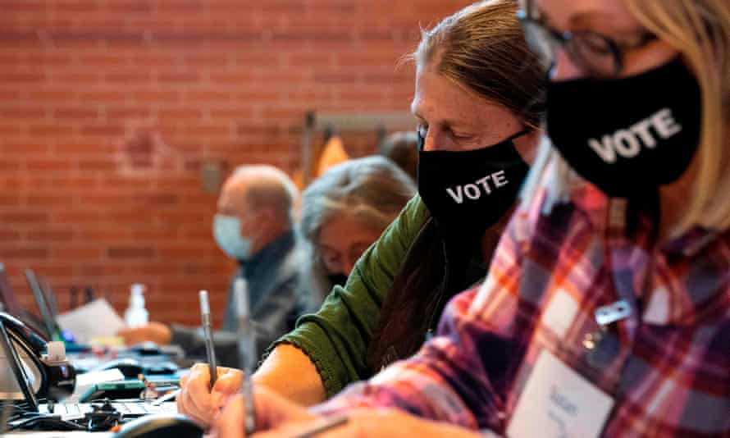
‘Today’s Democratic party is the opposite of the New Deal coalition.’ Photograph: Jason Connolly/AFP/Getty Images
Sat 19 Dec 2020 11.21 GMT

414

331

“If we are victorious in one more battle with the Romans, we shall be utterly ruined,” lamented King Pyrrhus of Epirus, whose costly triumph in 279 BC inspired the phrase “Pyrrhic victory”. In 2020, the Democratic party learned what King Pyrrhus was talking about. They recaptured the White House and narrowly held on to the House of Representatives. And if the Democrats win both Senate runoffs in Georgia, they may yet capture the Senate. But Republicans increased their share of the House, making it easier for them to recapture it in 2022, and they control a majority of state legislatures whose redistricting plans for the US Congress can help the Republican party.
Perhaps the greatest blow has been to the progressive interpretation of American politics. Most progressives have understood Trumpism as the last gasp of a dwindling, reactionary white male population. The future of the Democrats, it was said, lay with women and minorities. And yet in 2020, white men shifted more toward Biden than white women did. Black and brown Americans still voted mostly for Democrats, but there were significant shifts toward the Republicans among black and Hispanic voters, and all of the Republicans who took contested seats from the Democrats were minority group members or women.
What a winning coalition would look like depends on which issues unite the progressives and non-progressives
The mystery is not why the progressive wave that was supposed to establish a new era of progressive politics did not materialize. The mystery is why anybody believed that there would be a progressive wave. After all, progressives – defined as voters who are both socially and economically liberal – are a minority of the American electorate. According to Gallup in July 2020, only 26% of Americans identify themselves as liberal, compared with conservative (34%) or moderate (40%).
Advertisement
Not only are progressives a minority of American voters, they are also a minority of Democratic voters. According to Pew, in 2020 only 47% of Democrats described themselves as “liberal” or “very liberal”. The majority of Democrats are “moderate” (45%) or “conservative” (14%).
Voters of color are mostly Democratic, but that does not mean they are leftwing, as black support for Joe Biden over Bernie Sanders in the Democratic primary proved. Only 28% of black Americans and 30% of Hispanic Americans identify themselves as liberal.
In our two-party system, consistent progressives can be part of an electoral majority only if at least half of their Democratic coalition is less progressive. What a winning coalition would look like depends on which issues unite the progressives and non-progressives. There are only two choices. The Democrats can be an economically liberal party, with socially liberal and socially conservative wings, or they can be a socially liberal party, with economically liberal and economically conservative wings.
The New Deal/Great Society coalition that transformed the US in the mid-20th century, between the presidencies of Franklin D Roosevelt and Lyndon Johnson, was an example of the first kind of coalition. Most New Deal/Great Society Democrats supported economic programs that made life better for the working-class majority, from social security in the 1930s and Medicare and Medicaid in the 1960s to the minimum wage and pro-labor laws.
But even outside of the Democratic south, an anomalous region with an apartheid society and a backward economy, the Democratic party was not a socially liberal party. Northern trade union members were often Catholic, with traditional views of sex and marriage. The midwestern agrarian wing of the New Deal often combined populist support for farm families with religious fundamentalism, while northern progressive Democrats tended to be influenced by Social Gospel Protestantism. Asked about his political philosophy, Franklin Roosevelt responded: “I am a Christian and a Democrat.”

The roadmap to Democrats' long-term political power? A multiracial coalition
Read more

Today’s Democratic party is the opposite of the New Deal coalition. In the past generation, Bill Clinton and Barack Obama have transformed the Democrats into a socially liberal party, with economically liberal and economically conservative wings. Catholic and Protestant opponents of abortion have been made unwelcome in the party, and more recently Democrats have made support for gay marriage and gender fluidity litmus tests. But white, affluent college-educated Democrats tend to be less religious and more socially liberal than African American and Hispanic Democrats, giving Republicans the opportunity to pry away some Democratic voters of color with appeals to their values.
Making social liberalism a litmus test has allowed the Democrats to pick up some moderate Republicans and libertarians who are alienated by the Republican religious right. Biden won in part because most voters who supported the Libertarian party in 2016 appear to have voted for the Democratic presidential ticket in 2020. But attracting small-government free marketeers to the Democrats comes with a price. Republicans and libertarians who convert to the Democratic party tend to combine their liberalism on social issues like contraception, abortion and gay rights with hostility to higher taxes and more government spending. These converts reinforce the neoliberal wing of the Democratic party at the expense of the progressive wing.
The Clinton-Biden strategy of attracting more affluent white voters to the Democrats by stressing social liberalism rather than economic liberalism has already converted the party into something FDR and LBJ would not recognize. Of the 100 counties with the highest median incomes in the presidential election of 1980, the Democrats won only nine, with 91 going to the Republicans. In 2020, Biden won 57 to 43 for Trump. In 2018, the Democrats won back the House of Representatives by winning all 10 of the 10 wealthiest congressional districts, and 41 of 50 of the wealthiest.
These affluent voters prefer Democratic policies on abortion, gay rights and climate change – but only as long as they do not have to pay higher taxes. Back in 2015, Hillary Clinton promised that, if she were elected president, there would be no tax increases on households making less than $250,000. Biden went further this year, promising that taxes would not go up on households that make less than $400,000 a year.
Because it is impossible to fund the Nordic-style welfare state of which American progressives dream without raising taxes on the merely affluent as well as the super-rich, the Democratic party’s pandering to the affluent on taxes means that there will not be a Green New Deal, a major expansion of social insurance and social programs, or massive public investment in infrastructure. To appease the Democratic party’s new high-income voters and donors, the last two Democratic presidents, Barack Obama and Bill Clinton, abandoned their ambitious spending plans once elected and pivoted toward austerity and deficit reduction. It remains to be seen whether Biden will do the same.
Progressive Democrats have a choice. They can continue to be junior partners in a whiter and more gentrified Democratic party that nods toward racial justice and environmentalism and sexual freedom, but says no to a new New Deal. Or they can try to rebuild something like the New Deal coalition and win back sociallymoderate and conservative voters – some of them voters of color – who favor expanding social security and a higher minimum wage, but oppose affirmative action and abortion and decriminalizing illegal immigration. In either case, progressives must accept that they are only a quarter of the US population and cannot hope to win or exercise power without teaming up with people who reject many progressive views.
- Michael Lind is a professor at the Lyndon B Johnson School of Public Affairs and author of The New Class War: Saving Democracy from the Managerial Elite

Books
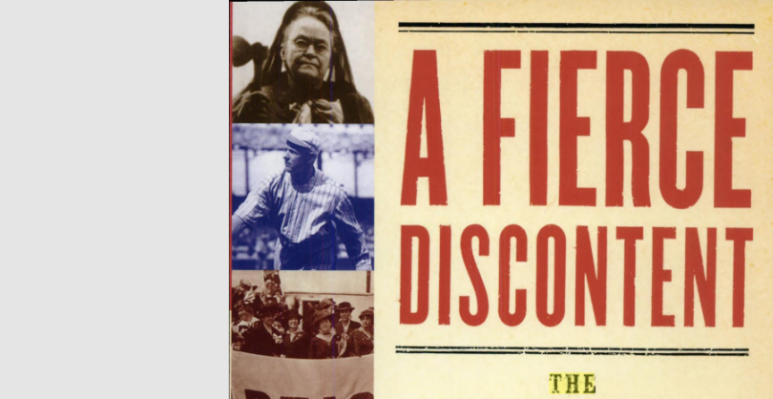
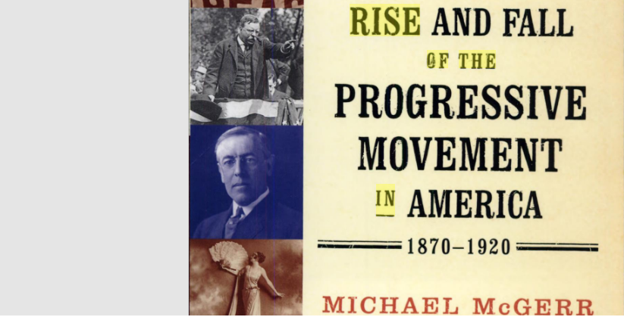

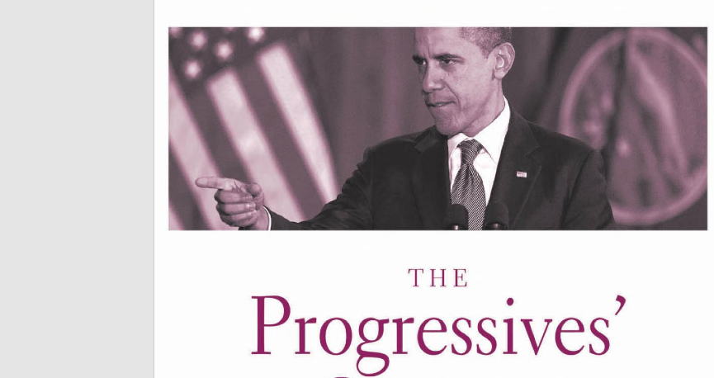
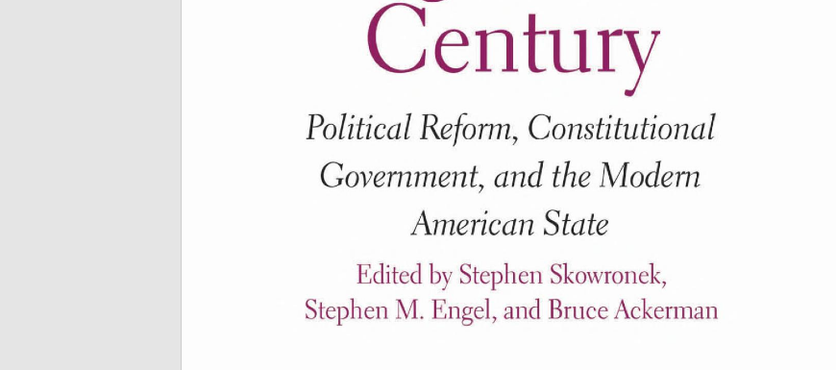
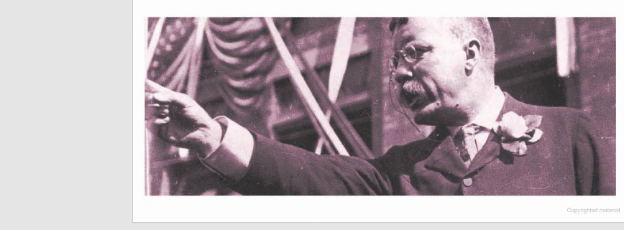

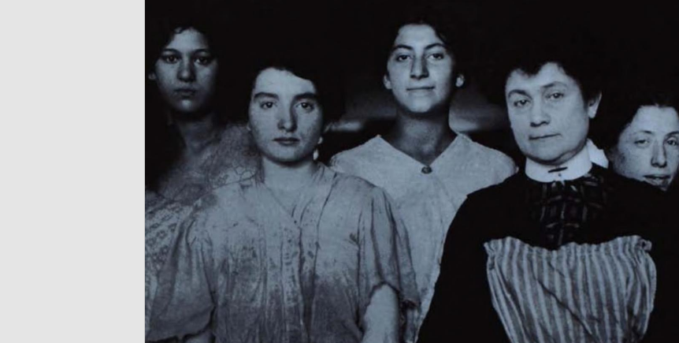
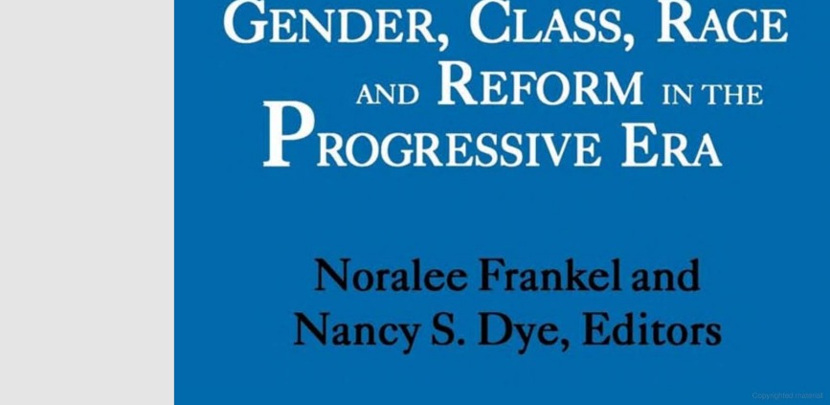
Academic Periodical Articles
International Journal of Progressive Education, Volume 13 Number 2, 2017 © 2017 INASED 7 American progressive education and the schooling of poor children: A brief history of a philosophy in practice Rebecca Gartei University of New York
Abstract
This paper provides a historical analysis of the past century of progressive education, within the general socio-political context of schooling within the US. The purpose of this review is to create a social, historical and philosophical context for understanding the current narrative of progressive education that exists in educational policy discussions today. Major scholarly works related to progressive education are situated within the political climate of the times of their publication. Over the course of this discussion an argument is presented that shows how progressive education has been related to the education and emancipation of disadvantaged children at different points according to the societal emphasis of the time. The final section of the paper proposes a radical form of emancipatory teaching that requires a wide range of abilities among teachers and is matched to elements of the moments in history when progressive education was most effective for poor children.
Paedagogica Historica, Vol. 41, Nos. 1&2, February 2005, pp. 275–288 ISSN 0030-9230 (print)/ISSN 1477-674X (online)/05/010275–14 © 2005 Stichting Paedagogica Historica DOI: 10.1080/0030923042000335583 Progressivism, Schools and Schools of Education: An American Romance David F. Labaree Taylor and Francis Ltd CPDH400116.sgm 10.1080/0030923042000335583 Paedagogica Historica 0030-9230 (print)/1477-674X (online) Original Article 2005 Stichting Paedagogica Historica 411 & 2 000000February 2005 DFLabaree dlabaree@stanford.edu
This paper tells a story about progressivism, schools and schools of education in twentieth-century America. Depending on one’s position in the politics of education, this story can assume the form of a tragedy or a romance, or perhaps even a comedy. The heart of the tale is the struggle for control of American education in the early twentieth century between two factions of the movement for progressive education. The administrative progressives won this struggle, and they reconstructed the organization and curriculum of American schools in a form that has lasted to the present day. Meanwhile the other group, the pedagogical progressives, who failed miserably in shaping what we do in schools, did at least succeed in shaping how we talk about schools. Professors in schools of education were caught in the middle of this dispute, and they ended up in an awkwardly compromised position. Their hands were busy—preparing teachers to work within the confines of the educational system established by the administrative progressives, and carrying out research to make this system work more efficiently. But their hearts were with the pedagogues. So they became the high priests of pedagogical progressivism, keeping this faith alive within the halls of the education school, and teaching the words of its credo to new generations of educators. Why is it that American education professors have such a longstanding, deeply rooted and widely shared rhetorical commitment to the progressive vision? The answer can be found in the convergence between the history of the education school and the history of the childcentered strand of progressivism during the early twentieth century. Historical circumstances drew them together so strongly that they became inseparable. As a result, progressivism became the ideology of the education professor. Education schools have their own legend about how this happened, which is a stirring tale about a marriage made in heaven, between an ideal that would save education and a stalwart champion that would fight the forces of traditionalism to make this ideal a reality. As is the case with most legends, there is some truth in this account. But here a different story is told. In this story, the union between pedagogical progressivism and the education school is not the result of mutual attraction but of something more enduring: mutual need. It was not a marriage of the strong but a wedding of the weak. Both were losers in their respective arenas: child-centered progressivism lost out in the struggle for control of American schools, and the education school lost out in the struggle for respect in American higher education. They needed each other, with one looking for a safe haven and the other looking for a righteous mission. As a result, education schools came to have a rhetorical commitment to progressivism that is so wide that, within these institutions, it is largely beyond challenge. At the same time, however, this progressive vision never came to dominate the practice of teaching and learning in schools—or even to reach deeply into the practice of teacher educators and researchers within education schools themselves.

The Winds of Change: The Progressive Movement and the Bureaucratization of Thrift
Heather A. Haveman, Hayagreeva Rao, Srikanth Paruchuri
First Published February 1, 2007 Research Article
https://doi.org/10.1177/000312240707200106
Article information


Abstract
This article examines how the values espoused by social movements become entrenched in political culture and spawn many new kinds of institutions, which in turn shape organizations far from movements' original targets. We demonstrate the diffuse and indirect effects of social movements, and also show that the diffusion of social-movement values is often selective—some are retained, while others are discarded. Our empirical site is the Progressive movement and the early thrift industry in California. We draw on social-movement research and organizational theory to argue that a new ideal of thrift, bureaucratized cooperation among strangers, replaced the original idea of thrift, friendly cooperation among neighbors. This shift was possible only after the modernizing temper of Progressivism gave rise to two institutions, the news media and role-model organizations that made bureaucracy culturally appropriate. The bureaucratization of thrift occurred even though it resulted in a centralization of power, which clashed with the Progressive ideal of equitably distributing power. Our study provides a compelling example of the fundamental revolution in American social organization in the twentieth century: the replacement of community-based groups by bureaucracies.
Visual Sources
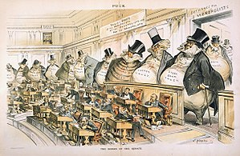
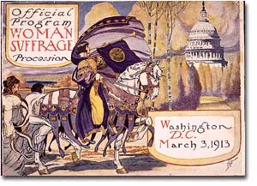
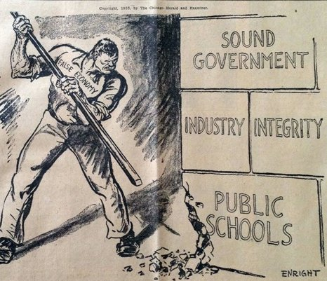
Websites




